library(ggplot2)

library(ggfortify)

library(forecast)

library(tseries)

US_candy_production <- candy_production

# class of dataset is numeric

str(US_candy_production)

# Assign more meaningful variable names to columns

colnames(US_candy_production)<-c("Period","candy_production")

# Convert data into time series dataset

attach(US_candy_production)

candyts<-ts(US_candy_production,c(1972,1),c(2017,8),12)

str(candyts)

## Time-Series [1:548] from 1972 to 2018: 85.7 71.8 66 64.6 65 ...

#EDA anaysis

# summary of data

summary(candyts)

# Check for missing values

sum(is.na(candyts))

# Check the frequency of the time series data

frequency(candyts)

# Check the cycle of the time series

cycle(candyts)

# Plot the raw data using the base plot function

plot(candyts,xlab="Date", ylab = "Candy Production as (%) of 2012 Production",main="Monthly US Candy Production from 1972 to 2017")

1st Graph

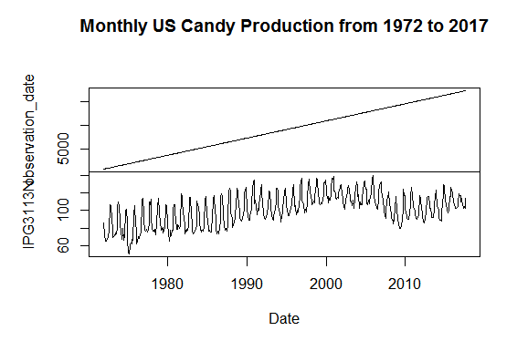

# Alternative to ggplot - ggfortify

autoplot(candyts) + labs(x ="Date", y = "Candy Production as (%) of 2012 Production", title="Monthly US Candy Production from 1972 to 2017")

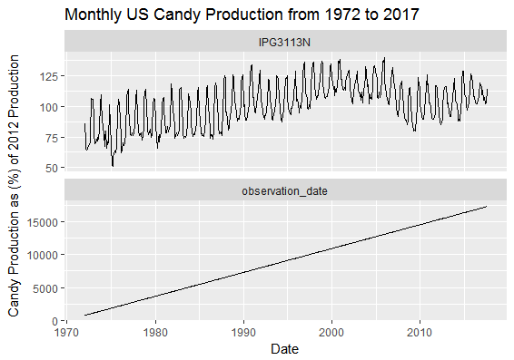

# to check seasonality

boxplot(candyts~cycle(candyts),xlab="Date", ylab = "Candy Production as (%) of 2012 Production" ,main ="Monthly US Candy Production from 1972 to 2017")

